The Center for the Church and Global AIDS - Backpack and Supply Distribution
TCDS works in 11 Dalit villages and has a representative in each village working on various programs. The backpack distribution to over 500 children took place in the village of Melathur. TCDS does a great job implementing this project. They organize the distribution by grade and village as each grade has different supply requirements.
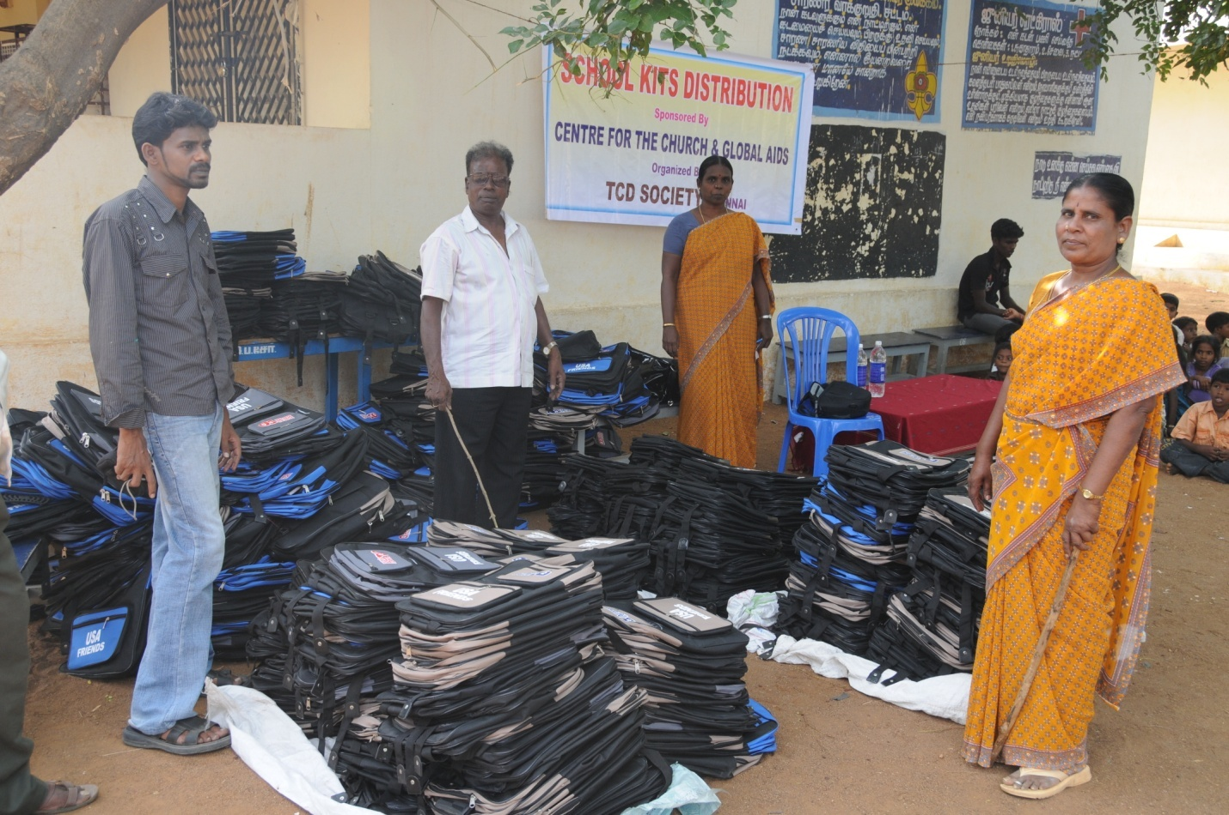
(From left to right) Vijay, Pastor Dhanaraj, Maria Pushpan, and one of the village representatives preparing for distribution
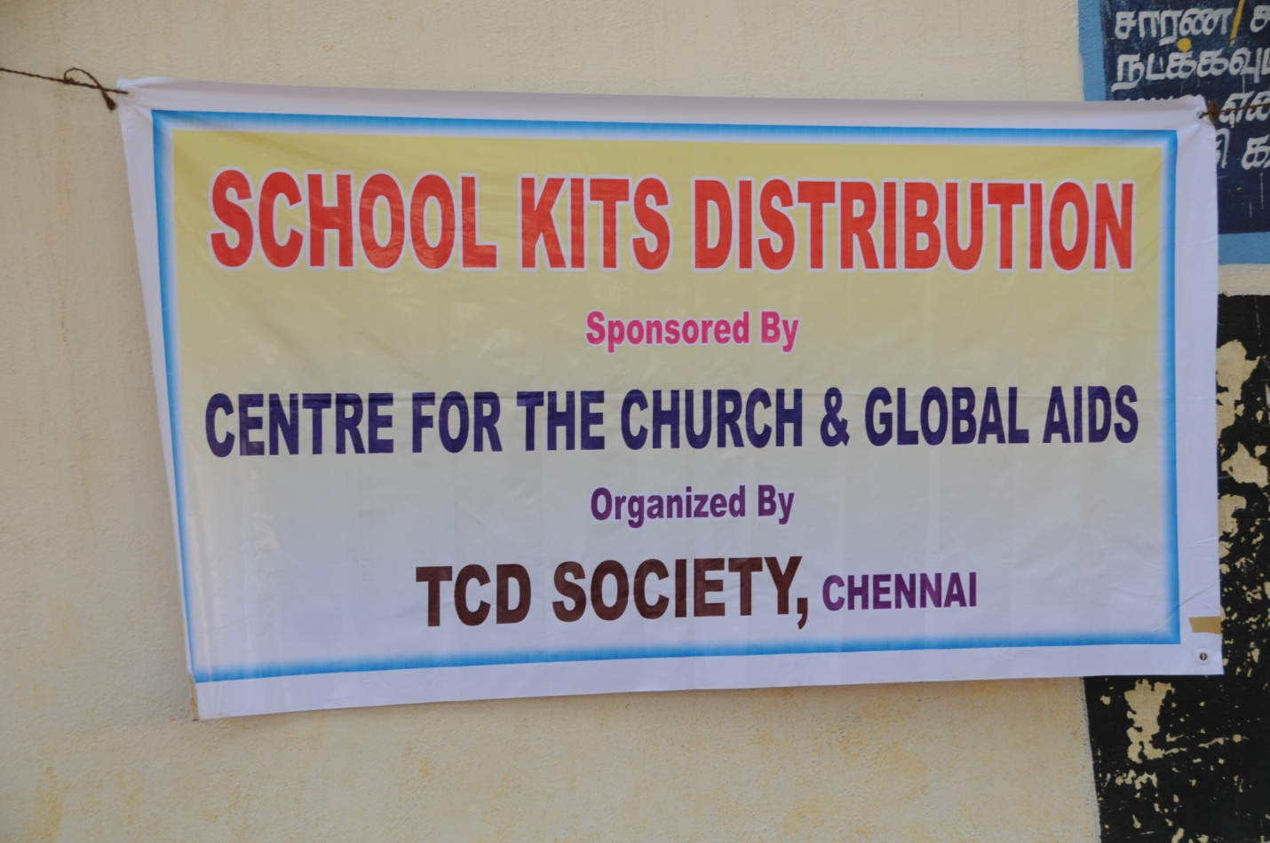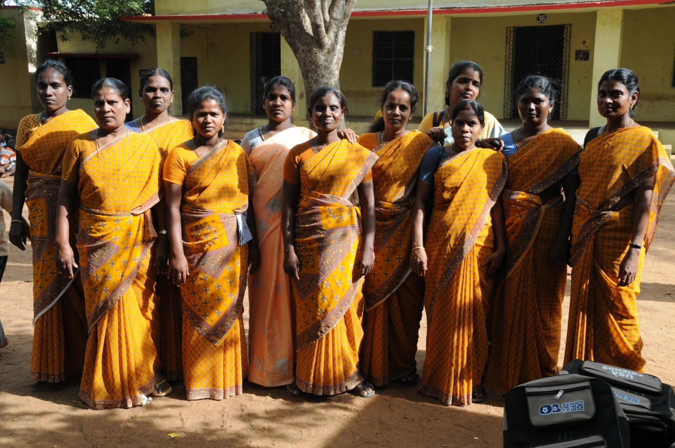The eleven representatives to the various villages in the Naduveerapattu area

The Dalit children were excited and appreciative – They say THANK YOU! I’ve never heard it said so many times. I guarantee this is the best Ambassador job the Center has to offer!
